Core Java – Missings 2
JDBC – Missings 6

Core Java – Missings

JDBC – Missings

JNDI - Java Naming and Directory Service
The Java Naming and Directory Service (JNDI) can be used to manage connections to the database server.

Using JNDI-datasource does not require the WAR file to be modified. We recommend you define JNDI environment vars or datasources in the 'context' file of your applications server.
For example,
- in Tomcat this file is called context.xml.
- in IBM Websphere we configure by loging console UI.

Advantages of using JNDI
- Standardizes the configuration of database connections.
- Enables the use of password encryption (passwords are currently stored as clear text strings). See Encrypting Passwords in Tomcat for more on encrypting your database passwords.
- Allows more fine-grained control over database connection pooling settings
So far, we placed connection details in properties file. Now in JNDI we place connection details on server side & we will connect to database by reading JNDI properties.
Tomcat – JNDI Example
CREATE TABLE `users` (
`id` int(11) NOT NULL AUTO_INCREMENT,
`username` varchar(45) NOT NULL,
`password` varchar(45) NOT NULL,
`email` varchar(45) NOT NULL,
PRIMARY KEY (`id`)
);

Configure JNDI in Tomcat
Create context.xml with below content & place inside below server location.
<Resource
name="jdbc/javaagain"
auth="Container"
type="javax.sql.DataSource"
maxActive="100"
maxIdle="30"
maxWait="10000"
driverClassName="com.mysql.jdbc.Driver"
url="jdbc:mysql://localhost:3306/javaagain"
username="root"
password="root"
/>

There are two places where the context.xml file can reside (create one if not exist):
- Inside /META-INF directory of a web application: the JNDI DataSource is only available to the application itself, thus it cannot be shared among other ones. In addition, this makes the configuration dependent on the application.
- Inside $CATALINA_BASE/conf directory: this is the preferred place because the JNDI DataSource will be available to all web applications and it’s independent of any applications.
I have placed in below tomcat folder
C:\apache-tomcat-9.0.44\conf

3. Configure web.xml
Add the following declaration into the web.xml file:
<resource-ref>
<description>DB Connection</description>
<res-ref-name>jdbc/jagaagain</res-ref-name>
<res-type>javax.sql.DataSource</res-type>
<res-auth>Container</res-auth>
</resource-ref>

4.Serlvet to Test
package demo.services;

import java.sql.Connection;
import java.sql.ResultSet;
import java.sql.Statement;
import javax.naming.Context;
import javax.naming.InitialContext;
import javax.sql.DataSource;
import javax.ws.rs.GET;
import javax.ws.rs.Path;
import javax.ws.rs.Produces;
import javax.ws.rs.core.MediaType;

@Path("/jndi")
public class JNDIService {

@GET
@Produces(MediaType.TEXT_HTML)
public String jndiTest() throws Exception {

Context initContext = new InitialContext();
Context envContext = (Context) initContext.lookup("java:comp/env");
DataSource ds = (DataSource) envContext.lookup("jdbc/javaagain");
Connection conn = ds.getConnection();

String result = "<h1> JNDI Data </h1>";

Statement statement = conn.createStatement();
String sql = "select username, email from users";
ResultSet rs = statement.executeQuery(sql);

int count = 1;
while (rs.next()) {
result = result + rs.getString("username")+":"+ rs.getString("email");
count++;
}
return result;
}
}

In IBM WebSpehere
1.Open the administrative console.
2.Click Resources > JDBC > JDBC providers > JDBC_provider > Data sources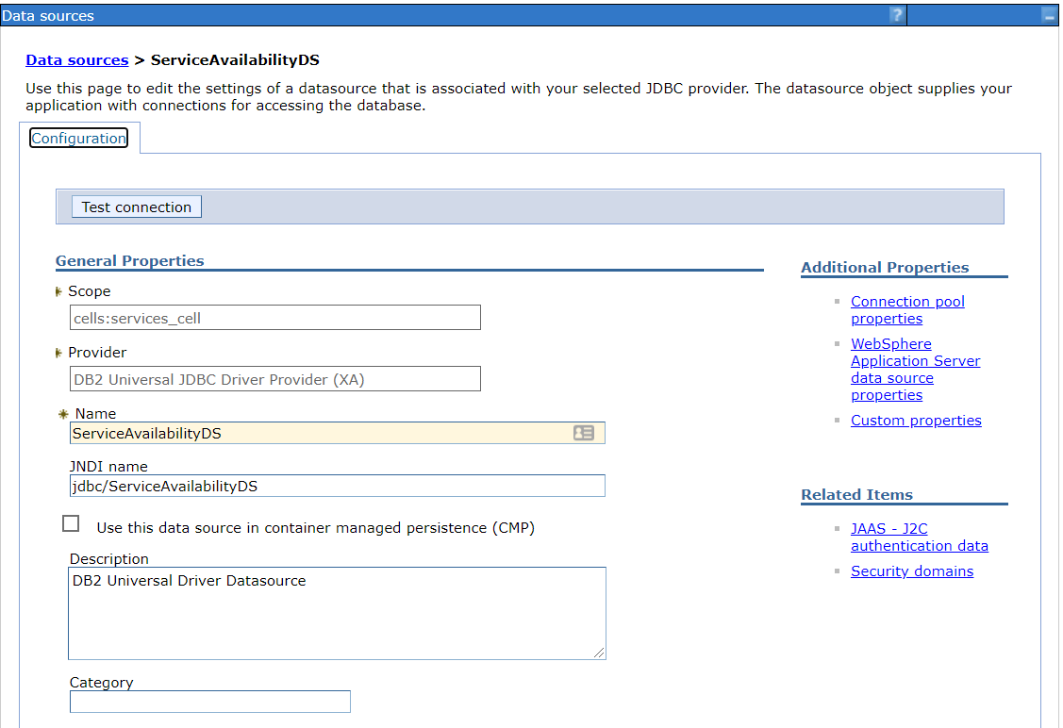
hibernate-config.xml
<property name="dataSource">
<bean class="org.springframework.jndi.JndiObjectFactoryBean">
<property name="jndiName" value="jdbc/studyRegistryDS" />
</bean>
</property>

java.naming.factory.initial=com.ibm.websphere.naming.WsnInitialContextFactory
java.naming.provider.url=iiop://172.28.18.225:10004

